PRACTICAL 2

**Merge Sort**

Code :

def merge(arr, l, m, r):

n1 = m - l + 1

n2 = r- m

L = [0] * (n1)

R = [0] * (n2)

for i in range(0 , n1):

L[i] = arr[l + i]

for j in range(0 , n2):

R[j] = arr[m + 1 + j]

i = 0

j = 0

k = l

while i < n1 and j < n2 :

if L[i] <= R[j]:

arr[k] = L[i]

i += 1

else:

arr[k] = R[j]

j += 1

k += 1

while i < n1:

arr[k] = L[i]

i += 1

k += 1

while j < n2:

arr[k] = R[j]

j += 1

k += 1

def mergeSort(arr,l,r):

if l < r:

m = (l+(r-1))//2

mergeSort(arr, l, m)

mergeSort(arr, m+1, r)

merge(arr, l, m, r)

arr = []

n = int(input("Enter number of Elements : "))

for i in range(n):

ele = int(input("Enter element : "))

arr.append(ele)

print ("List before Sorting : ", arr)

mergeSort(arr,0,n-1)

print ("List after Sorting : ", arr)

Output :

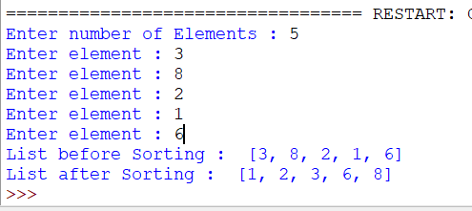

Time Complexity :

Worst Time : O(n*log(n))